Name: Sonu Kumari Father’s Name: Ramawtar Sain
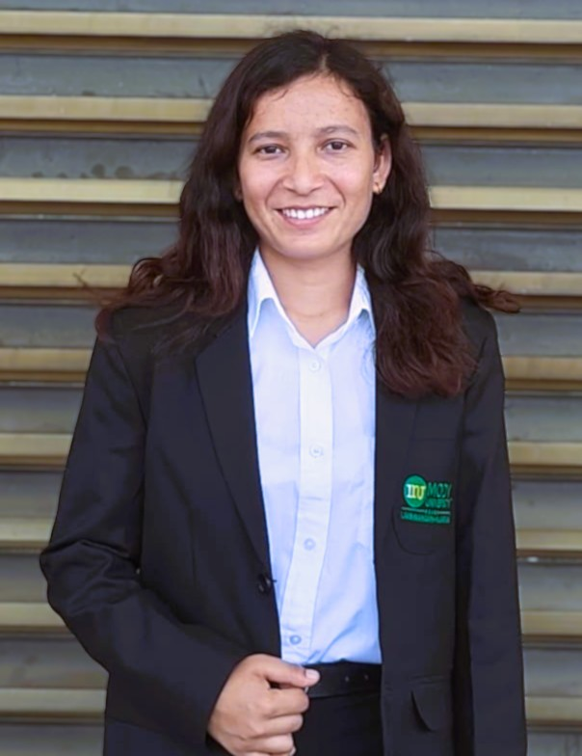
Photograph
College ID: 230223 Programme: B.tech.
Branch: CSE Nationality: Indian
Date of Birth: 15/05/2002 Contact No.: 8955706596
E-mail ID: sain35034@gmail.com
Permanent Address: Shekhisar Fatehpur,Sikar,RJ 332304
OBJECTIVE

An aspiring, highly motivated developer seeking opportunities to contribute to an organization’s growth while enhancing my skillset. Eager to apply problem-solving skills and innovative thinking to real-world challenges.

AREA OF INTEREST

  - Oriented Programming
  - Database Management Systems
  - Java Programming

EDUCATIONAL DETAILS

Mody University of Science and Technology, Rajasthan  B.Tech Computer Science /6.0 CGPA | 2023-2027
SHRI BALAJI S S SR SCH.NAGARDAS,FATEHPUR(SIKAR)  XII RBSE | 91.60% | 2021
GOVT PRAV SANS VID,SHEKHISAR(SIKAR)  X RBSE | 10.0 CGPA | 2019
LANGUAGES KNOWN (Read / Write / Speak)

  - HINDI
  - ENGLISH

TECHNICAL SKILLS

- Languages: Java, Python, C, SQL, HTML, CSS
- Database: Oracle, MySQL
- Relevant Coursework: Object Oriented Programming, Database Management Systems, Operating Systems
- IDEs and Tools: Visual Studio Code, GitHub, Turbo C, IDLE Shell 13.0, NetBeans
- Software: Multisim, SolidWorks, Canva
- MS Office: Word, PowerPoint, Excel

HOBBIES

- Painting, Sketching
- Gardening

I hereby declare that all the above given information is true to best of my knowledge. I am responsible for any discrepancy found.

